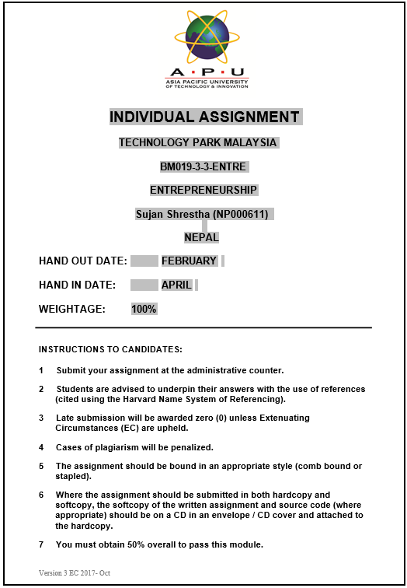

Table of Contents

**Background of Hem Raj Dhakal and IME Group** 1

**Source of Idea for the existence of IME Group** 4

**Opportunities Exploited by IME Group** 6

**Resources Mr. Hem Raj Dhakal used to start and then grow the business.** 8

**Challenges Faced Along the Way** 10

**Business strategy approach undertaken by the selected entrepreneur.** 12

**Conclusion** 14

**References** 15

Table of Figures

Figure 1: Portrait of Mr. Hem Raj Dhakal 1

Figure 2: IME Group Logo 2

Figure 3: Business Sectors of IME Group 4

Figure 4: IME Remittance 7

# **Background of Hem Raj Dhakal and IME Group**

Mr. Hem Raj Dhakal is a first-generation Nepalese serial entrepreneur who is well known for co-founding the IME conglomerate and was instrumental in the establishment of the remittance industry in the nation. He is visional for globalizing remittance services and expanding the business all around South Asia. This was done to make it easier and cheaper for millions of migrant workers that recite in Middle East and Malaysia to send the money home. This process altered the dynamics of remittances in South Asia in general, and Nepal specifically.

Mr. Hem Raj Dhakal, born on November 24, 1975, in Baglung, a district in western Nepal, completed his schooling in Baglung before coming to Kathmandu for further studies. He has achieved a Master of Business Studies (MBS) from Tribhuvan University, an Entrepreneurial Master's Program (EMP) from the Massachusetts Institute of Technology (MIT) and attended the London Business School (LBS) Growth Forum. He completed the Owner/President Management Program (OPM) at Harvard Business School. He serves as President of the Nepal Malaysia Chamber of Commerce and Industry, a member of the National Council of the Confederation of Nepalese Industries (CNI), and an executive committee member of the Nepal India Chamber of Commerce and Industry (NICCI) (Sharma, 2023).

Figure 1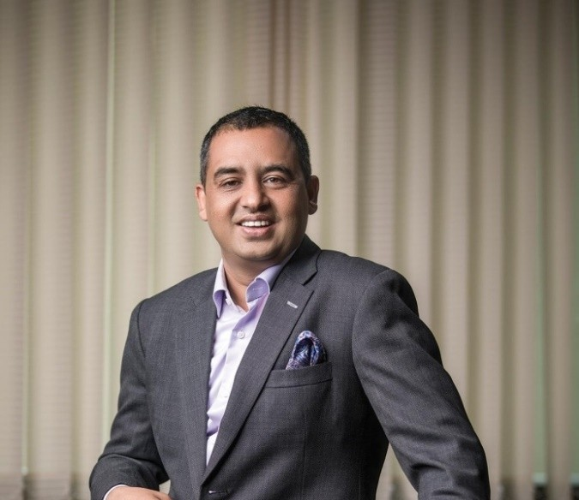: Portrait of Mr. Hem Raj Dhakal

The IME conglomerate is formed up of various companies that operate in different sectors such as banking, remittance, trading, IT, communications, energy, tourism, vehicles, insurance, and infotainment. Mr. Hem Raj Dhakal further extended the IME conglomerate into the worldwide market, establishing money service institutions in Malaysia, the United Kingdom, the United States, and Japan, as well as successfully completing the merger and acquisition of a few NASDAQS Fortune 500 companies.

This expansion not only has given a quick and dependable means for Nepalese living abroad to send money home, but it has also created numerous job possibilities and improved the economy of the nation. IME Remit is a market leader in Nepal's remittance business, with over 150,000 global locations and 5,400 franchise units in Nepal. Remittance inflows have helped to build a variety of industries, including housing, education, and healthcare, bringing financial security to Nepali people.

Figure 2: IME Group Logo

IME Group's key values include innovation, customer satisfaction, and social responsibility. Its story began with IME Remit, a pioneering enterprise in the Nepalese remittance market that thoroughly became a trusted and familiar name for tons of Nepalese around the world looking for secure and efficient money transferring service. Building on its existing success in remittances, IME further carried out its expansion of its portfolio to include IME Financial Institution, which provides a variety of banking and financial services. With an emphasis on equality and accessibility, IME Financial Institution has played a critical role in spreading financial services to previously neglected areas.

After finance, IME Group has also created a strong presence in trading, with businesses in consumer products, electronics, and building materials. Through smart relationships and a dedication to quality, IME has established itself as a dependable partner for businesses looking to traverse Nepal's complex market landscape.

Furthermore, IME Group has recognized the revolutionary power of technology, investing in IT solutions and e-commerce platforms. Using digital innovation, IME has improved operational efficiency and customer experience throughout its various business sectors (About IME Remit, 2024).

# **Source of Idea for the existence of IME Group**

Mr. Dhakal's vision helped to transform the family firm into a corporate one, with his team members now aligning with the group's slogan, Pioneering Spirit, which serves as the team's driving force. His mission is to empower children by providing chances and making them the group's proprietors. His team members own the company in addition to working for it. The IME conglomerate promotes social entrepreneurship and has already established startup funds to explore Nepal's business potential and provide chances for its youth. In 2009, he co-founded the IME Foundation, which conducts humanitarian activities.

Figure 3: Business Sectors of IME Group

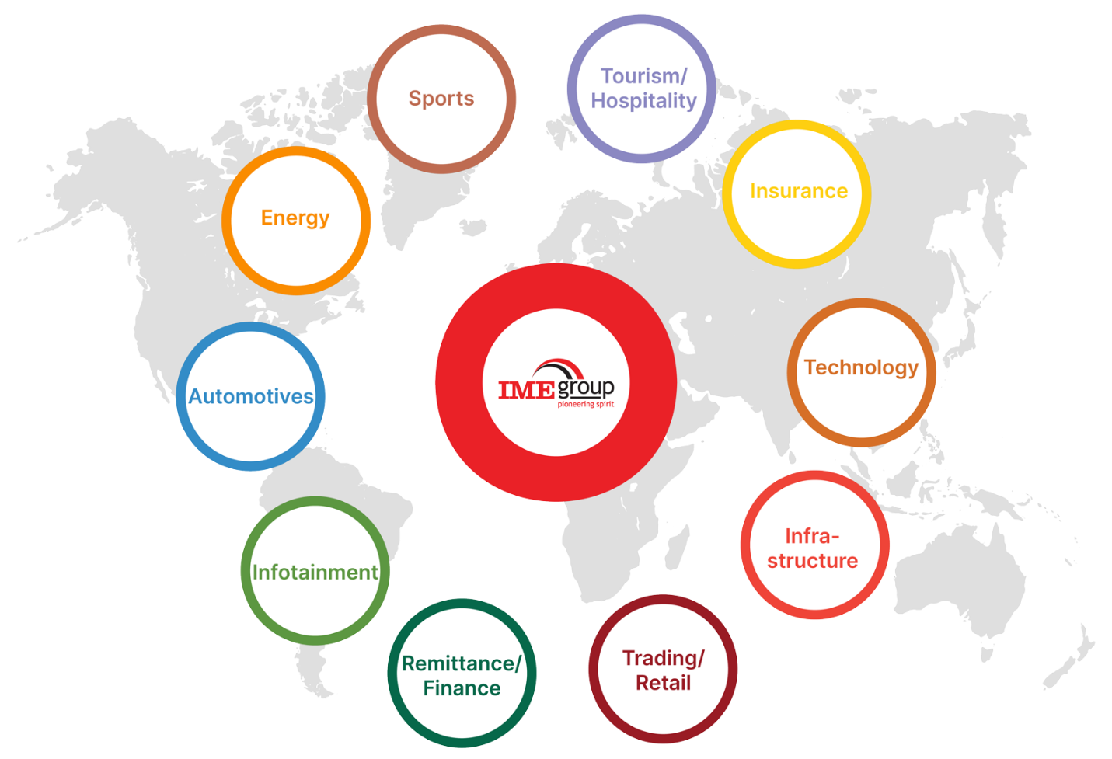

As Chairman of IME Group, Hem Raj Dhakal has built on his father, Chandra Prasad Dhakal's heritage while also adding his own vision and leadership to the company. His contributions reflected:

Strategic Vision and Expansion: Hem Raj Dhakal's leadership has been distinguished by a clear vision for the IME Group's expansion and diversification. Drawing on his experience and views, he has led projects to increase the group's position in a variety of industries, including banking, trade, and technology.

Embrace of Innovation: Hem Raj Dhakal understands the value of innovation and technology in corporate success. Under his leadership, IME Group has embraced digitization and technology innovations to improve operational efficiency and customer experience across all business verticals.

Focus on Partnerships and Alliances: Hem Raj Dhakal has developed strategic partnerships and alliances that have helped IME Group expand into new markets and industries. These collaborations have helped the company capitalize on growth possibilities and boost its competitive position by using synergies and complementary strengths.

Continued Commitment to Social Responsibility: Hem Raj Dhakal continues to support the IME Group's corporate social responsibility concept, building on his father's heritage. He continues to advocate activities that benefit society, notably in education, healthcare, and environmental sustainability.

To summarize, Chandra Prasad Dhakal and Hem Raj Dhakal have both played important roles in determining the existence and evolution of the IME Group. Their shared drive to entrepreneurship, social responsibility, and innovation has propelled IME Group to become Nepal's top conglomerate, recognized for its diversified portfolio and good influence on society (About IME Group, 2024).

# **Opportunities Exploited by IME Group**

During the journey which started in 2001, IME Group has seen a lot of growth and expansion through proper capitalization of wide range of opportunities in many sectors. Here are some important opportunities that the IME Group has effectively seized.

Remittance Market Growth

Recognition of the demand for remittance services which was growing more and more among Nepalese citizens working overseas, the IME Group founded IME Remit. By seizing this opportunity, IME Remit swiftly established and made itself known as a reliable platform for money transfers, taking a sizable piece of the remittance market while also ensuring secure and speedy transactions for its consumers.

Figure 4: IME Remittance



Financial Inclusion Initiatives

With a huge number of Nepal's population not having proper access to conventional banking services, the IME Group saw a potential to seize an opportunity to promote and expand its financial initiatives. IME Financial Institution was founded to bridge this gap by providing numerous banking and financial services according to the needs of both urban and rural places, thereby increasing access to formal financial services, and promoting economic empowerment all over the nation.

Expansion into Trading

With Nepal's booming trading sector, IME Group had an opportunity to diversify its portfolio and enter new market stream. Seizing this opportunity, the IME Group initiated trading, importing, and selling consumer products, technology, and building supplies. IME Group established and made itself well known as a leader in Nepal's trading scene by leveraging its broad network and market expertise.

Technological Advancements

The IME Group was quick to realize the value of technology, which was increasing day by day in operational efficiency and improving customer experience. By harvesting in IT solutions and e-commerce platforms, IME Group streamlined its operations, optimized its service delivery, and stayed ahead of changing market trends.

Strategic Partnerships and Alliances

Realizing the advantages of collaboration, IME Group formed strategic partnerships and collaborated with both local and international business companies. These collaborations allowed the IME Group to grab attention in the new markets, extend its product offerings.

Government Initiatives

IME Group generated numerous advantages from government initiatives supporting entrepreneurship, innovation, and economic development in Nepal. By optimizing its business plans to match the government aims and regulations, IME Group seizes the opportunity of supportive policies and incentives to drive its growth and expansion, thereby contributing to the nation’s overall economic development.

# **Resources Mr. Hem Raj Dhakal used to start and then grow the business.**

Mr. Hem Raj Dhakal played a pivotal role in the formation and growth of the IME Group, used numerous resources to launch and expand the group's operations. Here are the resources, Mr. Hem Raj Dhakal used to establish and expand IME Group:   
Financial Capital

Mr. Hem Raj Dhakal of course relied heavily on financial investments as this capital was critical in funding the initial operations of IME Group, including the initiation of different subsidiaries such as IME Remit and IME Financial Institution. As the IME group extended its grabbed sectors and diversified its portfolio, more financial resources were needed for growth, making strategic investments, and capture opportunities.

Human Capital

Mr. Hem Raj Dhakal properly understood the importance of human capital in achieving IME Group's success. He assembled and collected a skilled team of individuals with great backgrounds in finance, technology, marketing, operations, and other required fields. This professional staff was crucial of executing the conglomerate's strategy to grow more.  
Industry Knowledge and Expertise

Believing on his industry knowledge and expertise, Mr. Hem Raj Dhakal explored the growing opportunities in Nepal's commercial landscape and developed strategic plans to capitalize on them. His deep and vast knowledge regarding the market dynamics, consumer preferences, and regulatory frameworks offered a huge helping hand for IME Group to overcome hurdles, mitigate risks, and stay ahead of competitors in a fast-changing world.

Networking and Relationships

Mr. Hem Raj Dhakal knew his broad network of connections in the business community to form strategic partnerships, get capital, and extend into new sectors. These contacts provided significant insights, cooperation opportunities, and support for IME Group's growth and expansion in a variety of sectors and regions.   
Technology & Infrastructure

Recognizing the revolutionary power of technology, Mr. Hem Raj Dhakal hugely invested in modern infrastructure and IT solutions to improve operational efficiency, service delivery, and market competitiveness. IME Group used this cutting age and moder technology to simplify and optimize its business operations, streamline workflows, and bring creative solutions to its customers.

# **Challenges Faced Along the Way**

As the IME Group have achieved a lot, the journey from the beginning has not been without hurdles as here below are the major hurdles which were encountered along this journey of IME group.   
Regulatory and Compliance Difficulties

Adapting through regulatory frameworks and compliance standards, particularly in certain regulated industries like finance and remittance, has proven to become a hurdle for IME Group. Analyzing and adjusting to changes in policy of government, staying under strict laws, and getting proper licenses and permits have necessitated careful navigation and strategic planning.   
Competition, Market Dynamics

IME Group has many competitors in competitive marketplaces, going against both domestic and international businesses. The conglomerate's constant hurdle includes staying ahead of market changes and differentiating its goods to attract and retain clients to comply with the competition.

Technological Disruptions

Due to rapid advancements in technology, IME Group has faced both possibilities and problems in technology. The company faced certain obstacles in embracing digital transformation, being up to date on developing technologies, and integrating them into its operations while maintaining data security and integrity  
Operational Efficiency and Scalability

As the IME Group's operations and portfolio diversified, maintenance of operational efficiency and scalability became more challenging. Management of complicated supply chains, improvisation of procedures, and maintenance of smooth coordination across sub-branches necessitates ongoing improvement and strategic investment in infrastructure and resources.

Risk Management and Resilience

In today's fast-paced business climate, IME Group and Hem Raj Dhakal have faced various obstacles with variety of hazards, including economic volatility, currency fluctuations, geopolitical conflicts, and natural calamities. Creation and maintenance of strong risk management methods and plans, increasing resilience, and limiting possible hazards have all been very important to protect the conglomerate's interests and maintaining long-term viability (Duraisamy, 2022).  
Despite these problems, IME Group and Hem Raj Dhakal have shown tenacity, adaptability, and strategic foresight in overcoming obstacles and propelling continued development. By confronting problems front on, capitalizing on opportunities, and remaining true to their core beliefs, they have created IME Group as Nepal's leading conglomerate, positioned for future growth and influence.

# **Business strategy approach undertaken by the selected entrepreneur.**

Mr. Hem Raj Dhakal, a well-known entrepreneur, and the force behind IME Group, has experimented with and implemented various business strategy approaches that have greatly confirmed the conglomerate's success. Here's an evaluation of the main components of his business strategy:   
Diversification and Expansion

Differentiation along with diversification and expansion across many sectors has been a key part of Hem Raj Dhakal's business strategy. Recognizing the value of risk management and capitalization on emerging opportunities, this approach has led IME Group to extend its working sectors beyond remittances to include various other income sources such as banking, trading, technology, travel, education, healthcare, energy, and other areas. IME Group's diversification strategy has enabled it to distribute risk, grow into new revenue streams, and achieve long and lively growth.

Innovation and Adaptability

Hem Raj Dhakal has prioritized innovation and adaptability as crucial approach of the IME Group's business strategy. By embracing technological changes, adapting to more modern IT solutions, and exploiting digital platforms and expansions, IME Group has increased operational efficiency, customer experience, and market trends. Furthermore, Hem Raj Dhakal has shown a ready to change approach in order to adapt to changing market dynamics, regulatory frameworks, and customer preferences, enabling IME Group to remain nimble and adaptable to shifting business landscapes.

Customer-Centric Approach

Hem Raj Dhakal gives importance to client happiness and loyalty in his company practices. The IME Group's companies provide a variety of products and services suited to the needs and requirements of their consumers. IME Group has managed to establish and maintain great client relationships by providing high-quality products, tailored services, excellent customer support, and developing trust and loyalty over time.   
Strategic Partnerships and Alliances

Mr. Hem Raj Dhakal has grown into the market with strategic partnerships and alliances to further support the IME Group's growth and expansion. By partnering with domestic and international organizations, forming partnership with industry experts, and collaboration, IME Group has formed accessibility to new markets, increased its service offerings, and capitalized on synergies to generate mutually beneficial growth prospects.

Corporate Social Responsibility

Hem Raj Dhakal has combined corporate social responsibility (CSR) into the IME Group's business plan, recognizing and adapting to the need to give back to society. Through the IME Foundation and other CSR activities, the IME Group has fostered its investment in education, healthcare, environmental sustainability, and community development programs, benefiting society while improving its brand recognition and stakeholder relations.   
Overall, Hem Raj Dhakal's business strategy to further grow IME Group relies on diversification, innovation, customer-centricity, strategic partnerships, and corporate social responsibility. By efficiently implementing and adapting to this plan, he has pushed IME Group to a new height in the Nepal’s marketplace (Fleisher, 2018).

# **Conclusion**

In conclusion, the entrepreneurial vision and strategic approach of Mr. Hem Raj Dhakal have catapulted IME Group to glorious phase in Nepal's commercial scene. IME Group has formed and presented itself as one of the top conglomerates by offering a diverse and different portfolio, techniques which are creation, customer-centricity, strategic alliance and collaboration, and a dedication to corporate social responsibility. Despite experiencing hurdles along the road, Mr. Dhakal's ability of forward-thinking along with successful business strategies and approaches have helped IME Group negotiate complexities, capture opportunities, and drive long-term success. As IME Group extends its area and has a beneficial impact on society, Dhakal's business strategy approach shows his entrepreneurial aptitude and commitment to excellence.

# **References**

*About IME Group*. (2024, January 10). Retrieved April 17, 2024, from IME Group: https://imegroup.com.np/about/

*About IME Remit*. (2024, January 10). Retrieved April 17, 2024, from IME Remit: https://imeremit.com.np/about/

Duraisamy, M. (2022, June). Challenges in Business Management. *THE CHALLENGES ENCOUNTERED BY BUSINESS MANAGEMENT IN THE CURRENT SITUATION*. Retrieved April 17, 2024, from https://www.researchgate.net/publication/373069861_THE_CHALLENGES_ENCOUNTERED_BY_BUSINESS_MANAGEMENT_IN_THE_CURRENT_SITUATION

Fleisher, C. S. (2018, August). Business Strategy. doi:10.1002/9781119010722.iesc0015

Sharma, J. (2023, June 27). *Top 10 Entrepreneurs of Nepal*. Retrieved from Wap Nepal: https://wapnepal.com.np/top-10-entrepreneurs-nepal/